Configure Routers: OSPF MD5 authentication. NTP. to log messages to the syslog server.

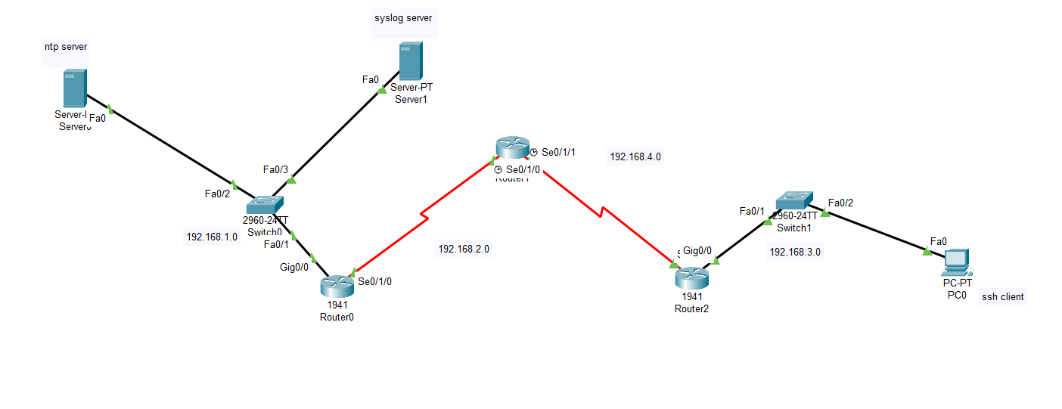

1️⃣ Router0 Configuration
enable
configure terminal
hostname R0
interface g0/0
ip address 192.168.1.1 255.255.255.0
no shutdown
interface s0/1/0
ip address 192.168.2.1 255.255.255.252
clock rate 64000
no shutdown
ip ospf message-digest-key 1 md5 cisco
ip ospf authentication message-digest
router ospf 1
router-id 1.1.1.1
network 192.168.1.0 0.0.0.255 area 0
network 192.168.2.0 0.0.0.3 area 0
ntp server 192.168.1.10
logging 192.168.1.20
logging trap debugging
service timestamps log datetime msec
end
write memory

2️⃣ Router1 Configuration
enable
configure terminal
hostname R1
interface s0/1/0
ip address 192.168.2.2 255.255.255.252
no shutdown
ip ospf message-digest-key 1 md5 cisco
ip ospf authentication message-digest
interface s0/1/1
ip address 192.168.4.1 255.255.255.252
clock rate 64000
no shutdown
ip ospf message-digest-key 1 md5 cisco
ip ospf authentication message-digest
router ospf 1
router-id 2.2.2.2
network 192.168.2.0 0.0.0.3 area 0
network 192.168.4.0 0.0.0.3 area 0
ntp server 192.168.1.10
logging 192.168.1.20
logging trap debugging
service timestamps log datetime msec
end
write memory

3️⃣ Router2 Configuration
enable
configure terminal
hostname R2
interface g0/0
ip address 192.168.3.1 255.255.255.0
no shutdown
interface s0/1/1
ip address 192.168.4.2 255.255.255.252
no shutdown
ip ospf message-digest-key 1 md5 cisco
ip ospf authentication message-digest
router ospf 1
router-id 3.3.3.3
network 192.168.3.0 0.0.0.255 area 0
network 192.168.4.0 0.0.0.3 area 0
ntp server 192.168.1.10
logging 192.168.1.20
logging trap debugging
service timestamps log datetime msec
end
write memory

4️⃣ Switch0 Configuration (Servers LAN)
enable
configure terminal
hostname SW0
interface vlan1
ip address 192.168.1.2 255.255.255.0
no shutdown
ip default-gateway 192.168.1.1
logging 192.168.1.20
end
write

5️⃣ Switch1 Configuration (PC LAN)
enable
configure terminal
hostname SW1
interface vlan1
ip address 192.168.3.2 255.255.255.0
no shutdown
ip default-gateway 192.168.3.1
logging 192.168.1.20
end
write

6️⃣ NTP Server Configuration
On Server (192.168.1.10) in Packet Tracer:
Services → NTP → ON
IP configuration:
IP Address: 192.168.1.10
Mask: 255.255.255.0
Gateway: 192.168.1.1

7️⃣ Syslog Server Configuration
On Server (192.168.1.20):
Services → SYSLOG → ON
IP configuration:
IP Address: 192.168.1.20
Mask: 255.255.255.0
Gateway: 192.168.1.1

8️⃣ PC Configuration
PC0:
IP: 192.168.3.10
Mask: 255.255.255.0
Gateway: 192.168.3.1

9️⃣ Verification Commands

Check OSPF neighbors
show ip ospf neighbor

Check OSPF routes
show ip route ospf

Check NTP sync
show ntp associations

Check logging
show logging

Ping test
ping 192.168.1.10
ping 192.168.1.20

2.
Configure AAA Authentication
a.
Configure a local user account on Router and configure authenticate on the console
and vty lines using local AAA
b.
Verify local AAA authentication from the Router console and the PC-A client

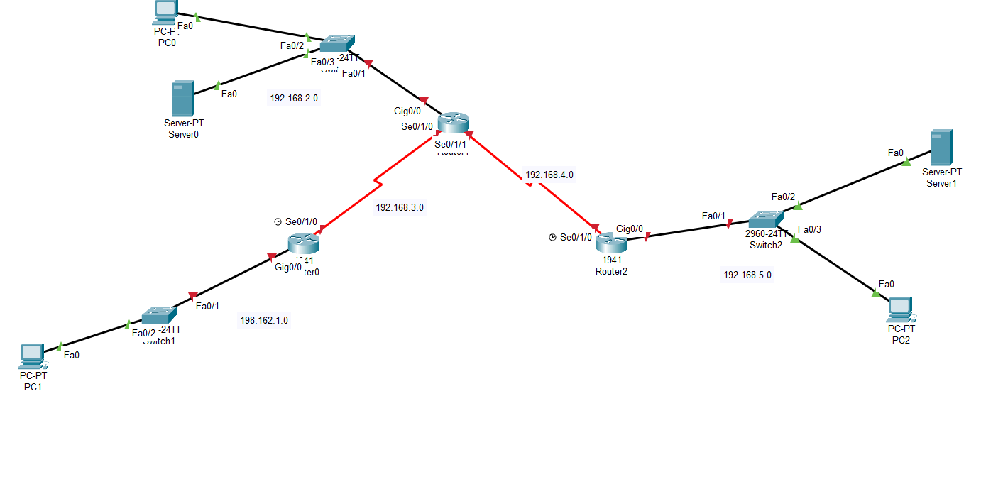

1️⃣ Addressing Plan (Based on Your Diagram)
Device | Interface | IP Address
Router0 | G0/0 | 198.162.1.1 /24
Router0 | S0/1/0 | 192.168.3.1 /30
Router1 | G0/0 | 192.168.2.1 /24
Router1 | S0/1/0 | 192.168.3.2 /30
Router1 | S0/1/1 | 192.168.4.1 /30
Router2 | G0/0 | 192.168.5.1 /24
Router2 | S0/1/1 | 192.168.4.2 /30
PC Networks:
Device | IP | Gateway
PC0 | 192.168.2.10 | 192.168.2.1
PC1 | 198.162.1.10 | 198.162.1.1
PC2 | 192.168.5.10 | 192.168.5.1

2️⃣ Router0 Configuration
enable
configure terminal
hostname Router0
interface g0/0
ip address 198.162.1.1 255.255.255.0
no shutdown
interface s0/1/0
ip address 192.168.3.1 255.255.255.252
clock rate 64000
no shutdown
router ospf 1
network 198.162.1.0 0.0.0.255 area 0
network 192.168.3.0 0.0.0.3 area 0
aaa new-model
username admin privilege 15 secret cisco123
aaa authentication login default local
ip domain-name lab.local
crypto key generate rsa
1024
ip ssh version 2
line console 0
login authentication default
exit
line vty 0 4
login authentication default
transport input telnet ssh
exit
end
write memory

3️⃣ Router1 Configuration
enable
configure terminal
hostname Router1
interface g0/0
ip address 192.168.2.1 255.255.255.0
no shutdown
interface s0/1/0
ip address 192.168.3.2 255.255.255.252
no shutdown
interface s0/1/1
ip address 192.168.4.1 255.255.255.252
clock rate 64000
no shutdown
router ospf 1
network 192.168.2.0 0.0.0.255 area 0
network 192.168.3.0 0.0.0.3 area 0
network 192.168.4.0 0.0.0.3 area 0
aaa new-model
username admin privilege 15 secret cisco123
aaa authentication login default local
ip domain-name lab.local
crypto key generate rsa
1024
ip ssh version 2
line console 0
login authentication default
exit
line vty 0 4
login authentication default
transport input telnet ssh
exit
end
write memory

4️⃣ Router2 Configuration
enable
configure terminal
hostname Router2
interface g0/0
ip address 192.168.5.1 255.255.255.0
no shutdown
interface s0/1/1
ip address 192.168.4.2 255.255.255.252
no shutdown
router ospf 1
network 192.168.5.0 0.0.0.255 area 0
network 192.168.4.0 0.0.0.3 area 0
aaa new-model
username admin privilege 15 secret cisco123
aaa authentication login default local
ip domain-name lab.local
crypto key generate rsa
1024
ip ssh version 2
line console 0
login authentication default
exit
line vty 0 4
login authentication default
transport input telnet ssh
exit
end
write memory

5️⃣ Switch Configuration (Optional)
enable
configure terminal
hostname Switch1
interface vlan1
ip address 198.162.1.2 255.255.255.0
no shutdown
ip default-gateway 198.162.1.1
end
write
(Repeat similar config for other switches with their subnet.)

6️⃣ PC Configuration

PC0
IP: 192.168.2.10
Mask: 255.255.255.0
Gateway: 192.168.2.1

PC1
IP: 198.162.1.10
Mask: 255.255.255.0
Gateway: 198.162.1.1

PC2
IP: 192.168.5.10
Mask: 255.255.255.0
Gateway: 192.168.5.1

7️⃣ Verify AAA Authentication from Console
Disconnect console and reconnect.
Router will display:
User Access Verification
Username:
Password:
Enter:
Username: admin
Password: cisco123

8️⃣ Verify AAA from PC Client
On PC Command Prompt:
telnet 192.168.2.1
or
ssh -l admin 192.168.2.1
Output:
Username: admin
Password: cisco123
Router>

9️⃣ Verification Commands (Router)
Check AAA:
show running-config | include aaa
Check user:
show running-config | include username
Check SSH:
show ip ssh
Check OSPF neighbors:
show ip ospf neighbor

